Webhook Handling
# Source: AI Source: Provided by: [Data Path: Persons Table -> ID Column: 1, Name_En Column: Motasem Essam] -> From: [ChatGPT] on [1/21/2026]
In Custom Bank Integrations, a webhook is a server-to-server notification sent by the bank’s payment system to your server to confirm the status of a transaction (e.g., success, failure, or timeout).
While technically "optional," webhook handling is critically important for ensuring that your system accurately records payment results, even if the customer closes the browser or loses internet during checkout.

🎯 Purpose of Webhook Handling
# Source: AI Source: Provided by: [Data Path: Persons Table -> ID Column: 1, Name_En Column: Motasem Essam] -> From: [ChatGPT] on [1/21/2026]
- Automatically receive payment status updates from the bank.
- Update your order/payment records securely in real-time.
- Avoid relying only on front-end redirects, which are unreliable.
- Enable asynchronous handling of delayed or background transaction events.

📦 Common Events Handled via Webhooks
# Source: AI Source: Provided by: [Data Path: Persons Table -> ID Column: 1, Name_En Column: Motasem Essam] -> From: [ChatGPT] on [1/21/2026]
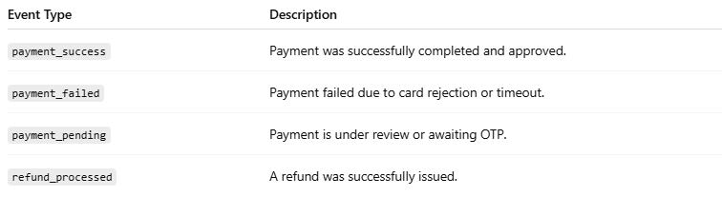
Event Type | Description
payment_success | Payment was successfully completed and approved.
payment_failed | Payment failed due to card rejection or timeout.
payment_pending | Payment is under review or awaiting OTP.
refund_processed | A refund was successfully issued.

🔧 How Webhook Handling Works

1. Bank Sends a Webhook
# Source: AI Source: Provided by: [Data Path: Persons Table -> ID Column: 1, Name_En Column: Motasem Essam] -> From: [ChatGPT] on [1/21/2026]
- After a payment is completed (success/fail), the bank sends a POST request to your server.
- The payload includes the order ID, status, and usually a signature to validate authenticity.

2. Your Server Receives the Webhook
# Source: AI Source: Provided by: [Data Path: Persons Table -> ID Column: 1, Name_En Column: Motasem Essam] -> From: [ChatGPT] on [1/21/2026]
- Your backend endpoint (e.g., /webhook/payment) accepts the request.
- You verify the signature or hash (HMAC, SHA256, etc.) to ensure it's from the bank.

3. You Update Your Records
# Source: AI Source: Provided by: [Data Path: Persons Table -> ID Column: 1, Name_En Column: Motasem Essam] -> From: [ChatGPT] on [1/21/2026]
- Based on the webhook, you mark the transaction as:
  - Paid
  - Failed
  - Pending
- You can also trigger follow-up actions like:
  - Sending a confirmation email
  - Unlocking premium content
  - Updating an invoice

🛡️ Security Measures for Webhooks
# Source: AI Source: Provided by: [Data Path: Persons Table -> ID Column: 1, Name_En Column: Motasem Essam] -> From: [ChatGPT] on [1/21/2026]
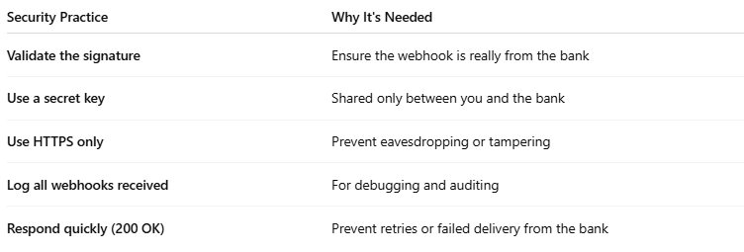
Security Practice | Why It's Needed
Validate the signature | Ensure the webhook is really from the bank
Use a secret key | Shared only between you and the bank
Use HTTPS only | Prevent eavesdropping or tampering
Log all webhooks received | For debugging and auditing
Respond quickly (200 OK) | Prevent retries or failed delivery from the bank

🧪 Example Webhook Payload
# Source: AI Source: Provided by: [Data Path: Persons Table -> ID Column: 1, Name_En Column: Motasem Essam] -> From: [ChatGPT] on [1/21/2026]
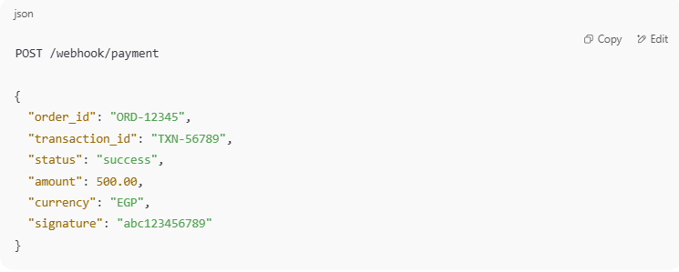
POST /webhook/payment

{
"order_id": "ORD-12345",
"transaction_id": "TXN-56789",
"status": "success",
"amount": 500.00,
"currency": "EGP",
"signature": "abc123456789"
}

You must:
- Lookup the order ID in your system.
- Verify the signature.
- Update the status in your database.

✅ Best Practices
# Source: AI Source: Provided by: [Data Path: Persons Table -> ID Column: 1, Name_En Column: Motasem Essam] -> From: [ChatGPT] on [1/21/2026]
- Always treat webhooks as the source of truth for final transaction status.
- Implement idempotency (only update a transaction once, even if the webhook is sent twice).
- Send a quick 200 OK response after processing — banks often retry if your server is slow or unresponsive.
- Use queue systems if processing takes longer (e.g., RabbitMQ, Redis queues).

🧠 Summary
# Source: AI Source: Provided by: [Data Path: Persons Table -> ID Column: 1, Name_En Column: Motasem Essam] -> From: [ChatGPT] on [1/21/2026]
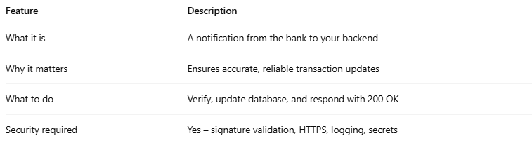
Feature | Description
What it is | A notification from the bank to your backend
Why it matters | Ensures accurate, reliable transaction updates
What to do | Verify, update database, and respond with 200 OK
Security required | Yes – signature validation, HTTPS, logging, secrets

